Name: Omobola Olajide

[omobola.olajide@womentechsters.org](mailto:omobola.olajide@womentechsters.org)

PRACTICAL ACTIVITY 3

**Part 1: Practical Activity Week 3**

**This week you will entirely learn how to manage and access different processes and**

**statistics in a Linux environment.**

**Perform the following activities and screenshot your output from Ubuntu- Terminal.**

Do through research for the different commands you will utilize.

1. List the processes for the current shell.

"Ps"

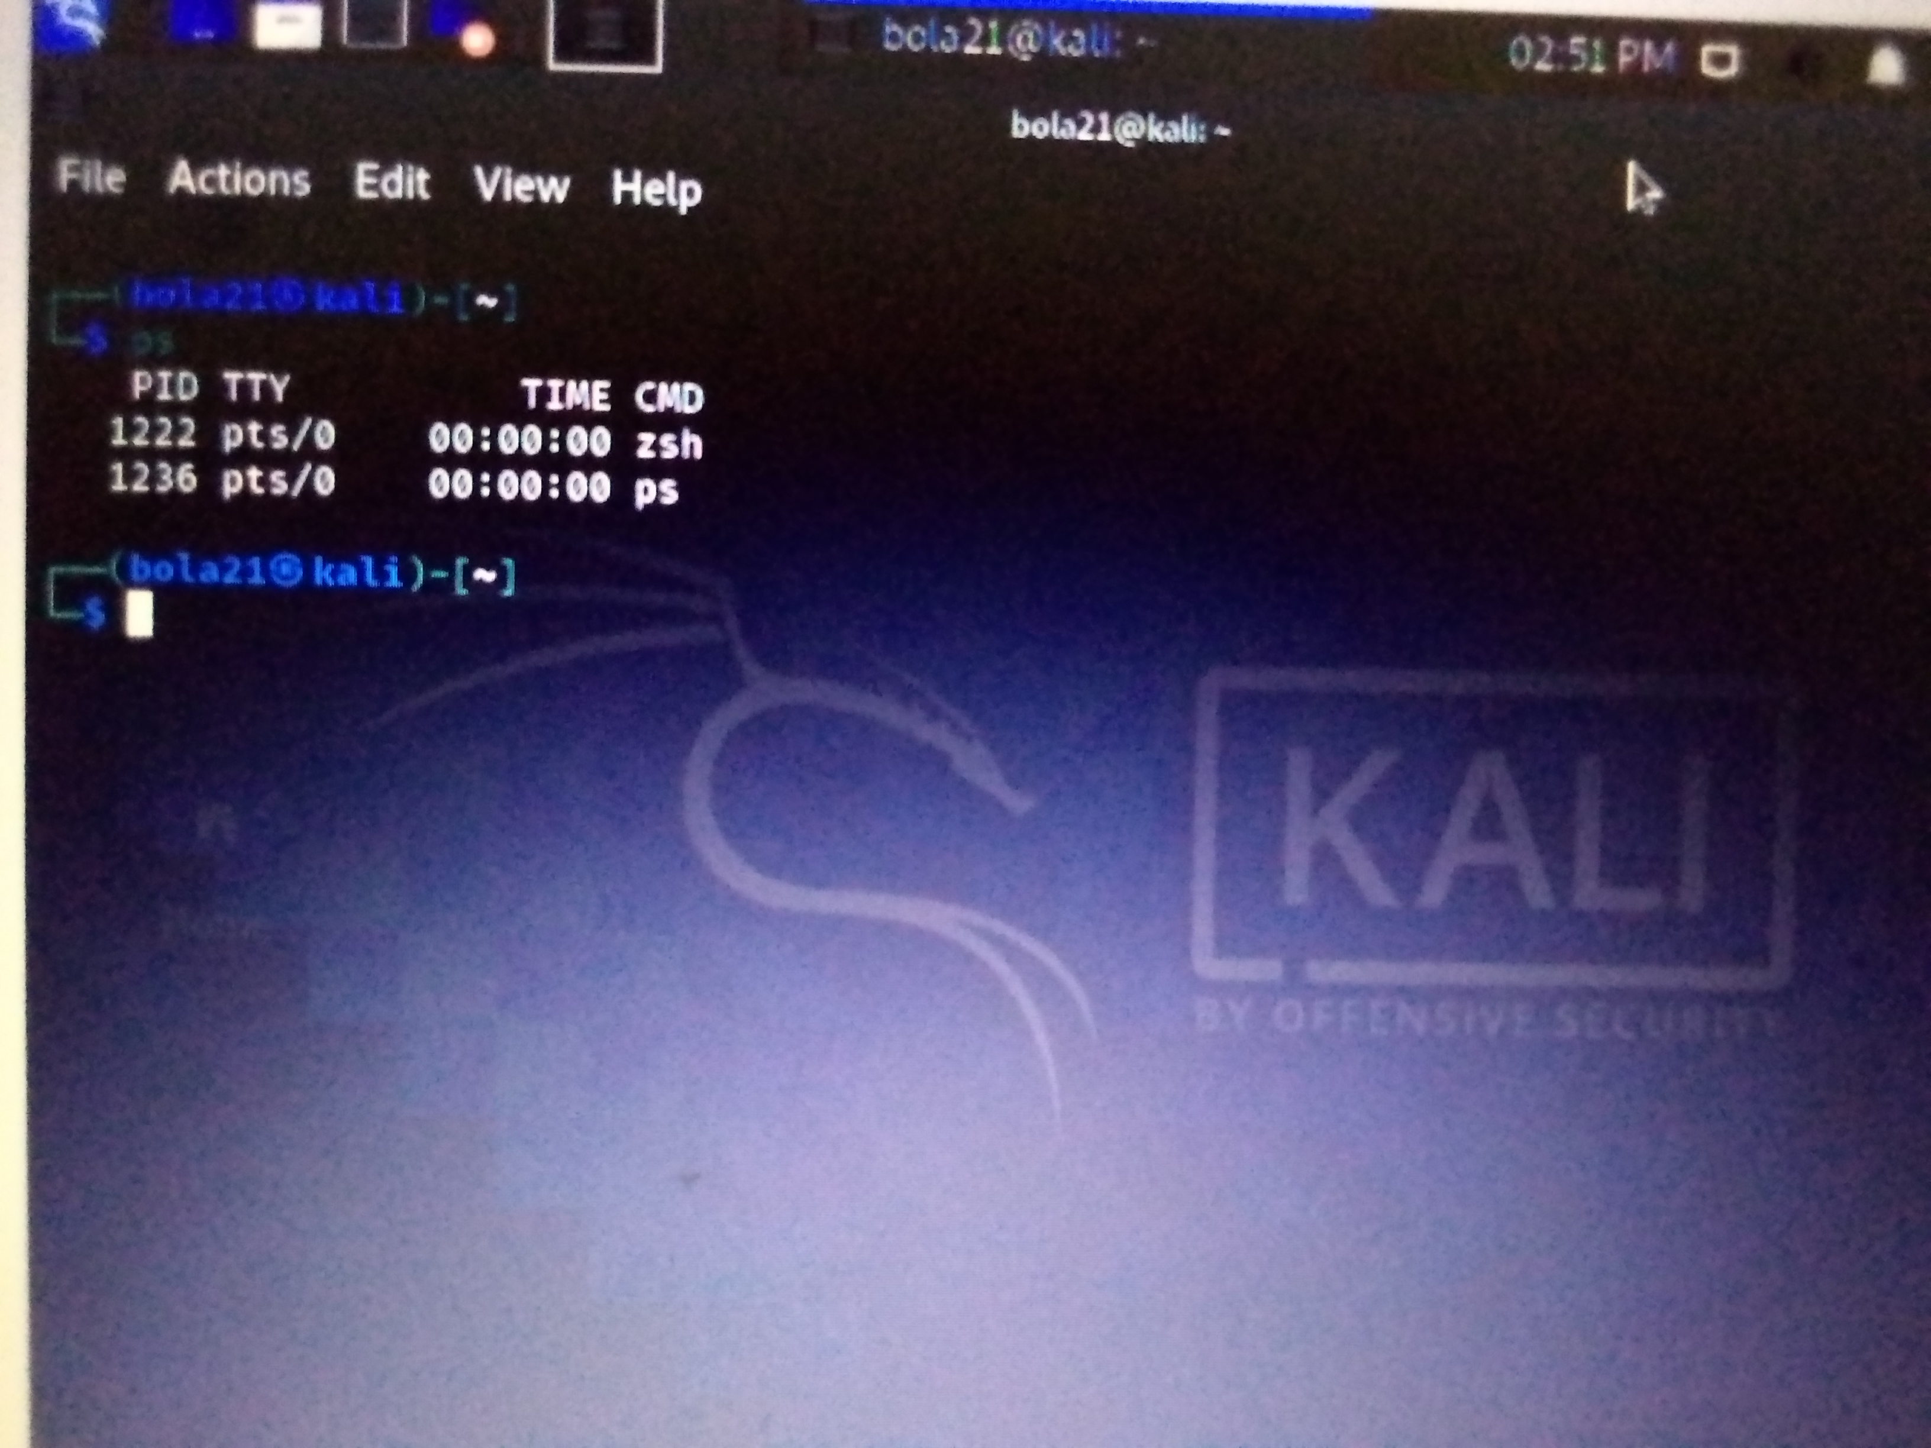

2. Display information about processes.

"Ps aux"

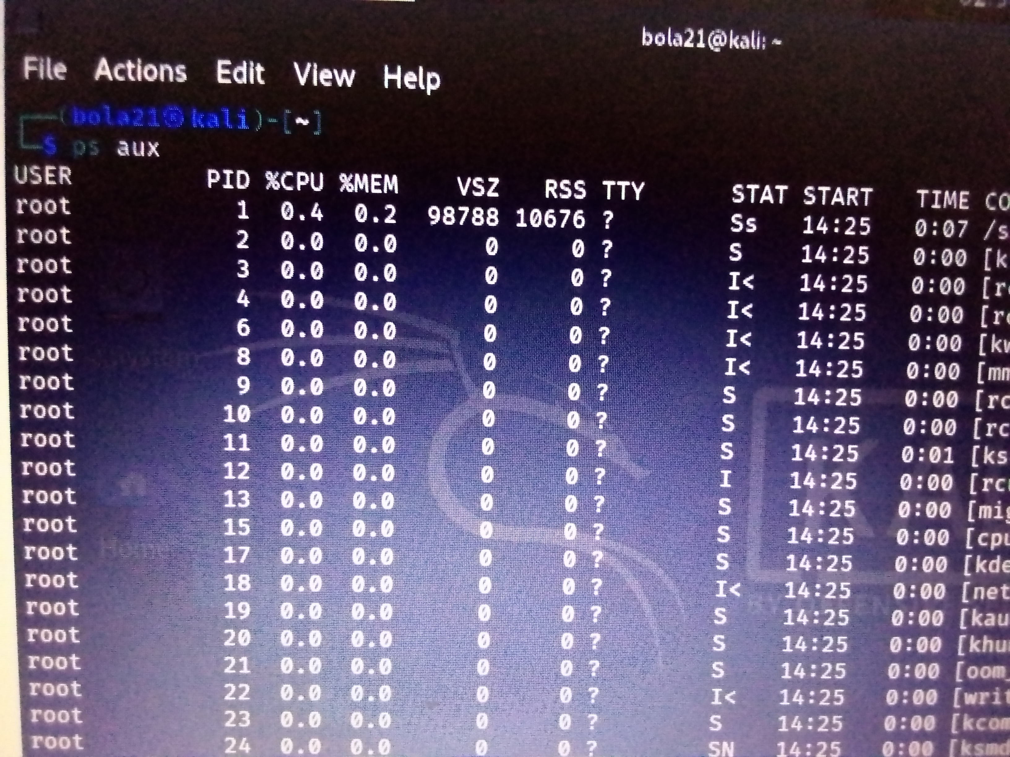

3. Display the global priority of a process

and find out the column that provides.

"ps -al"

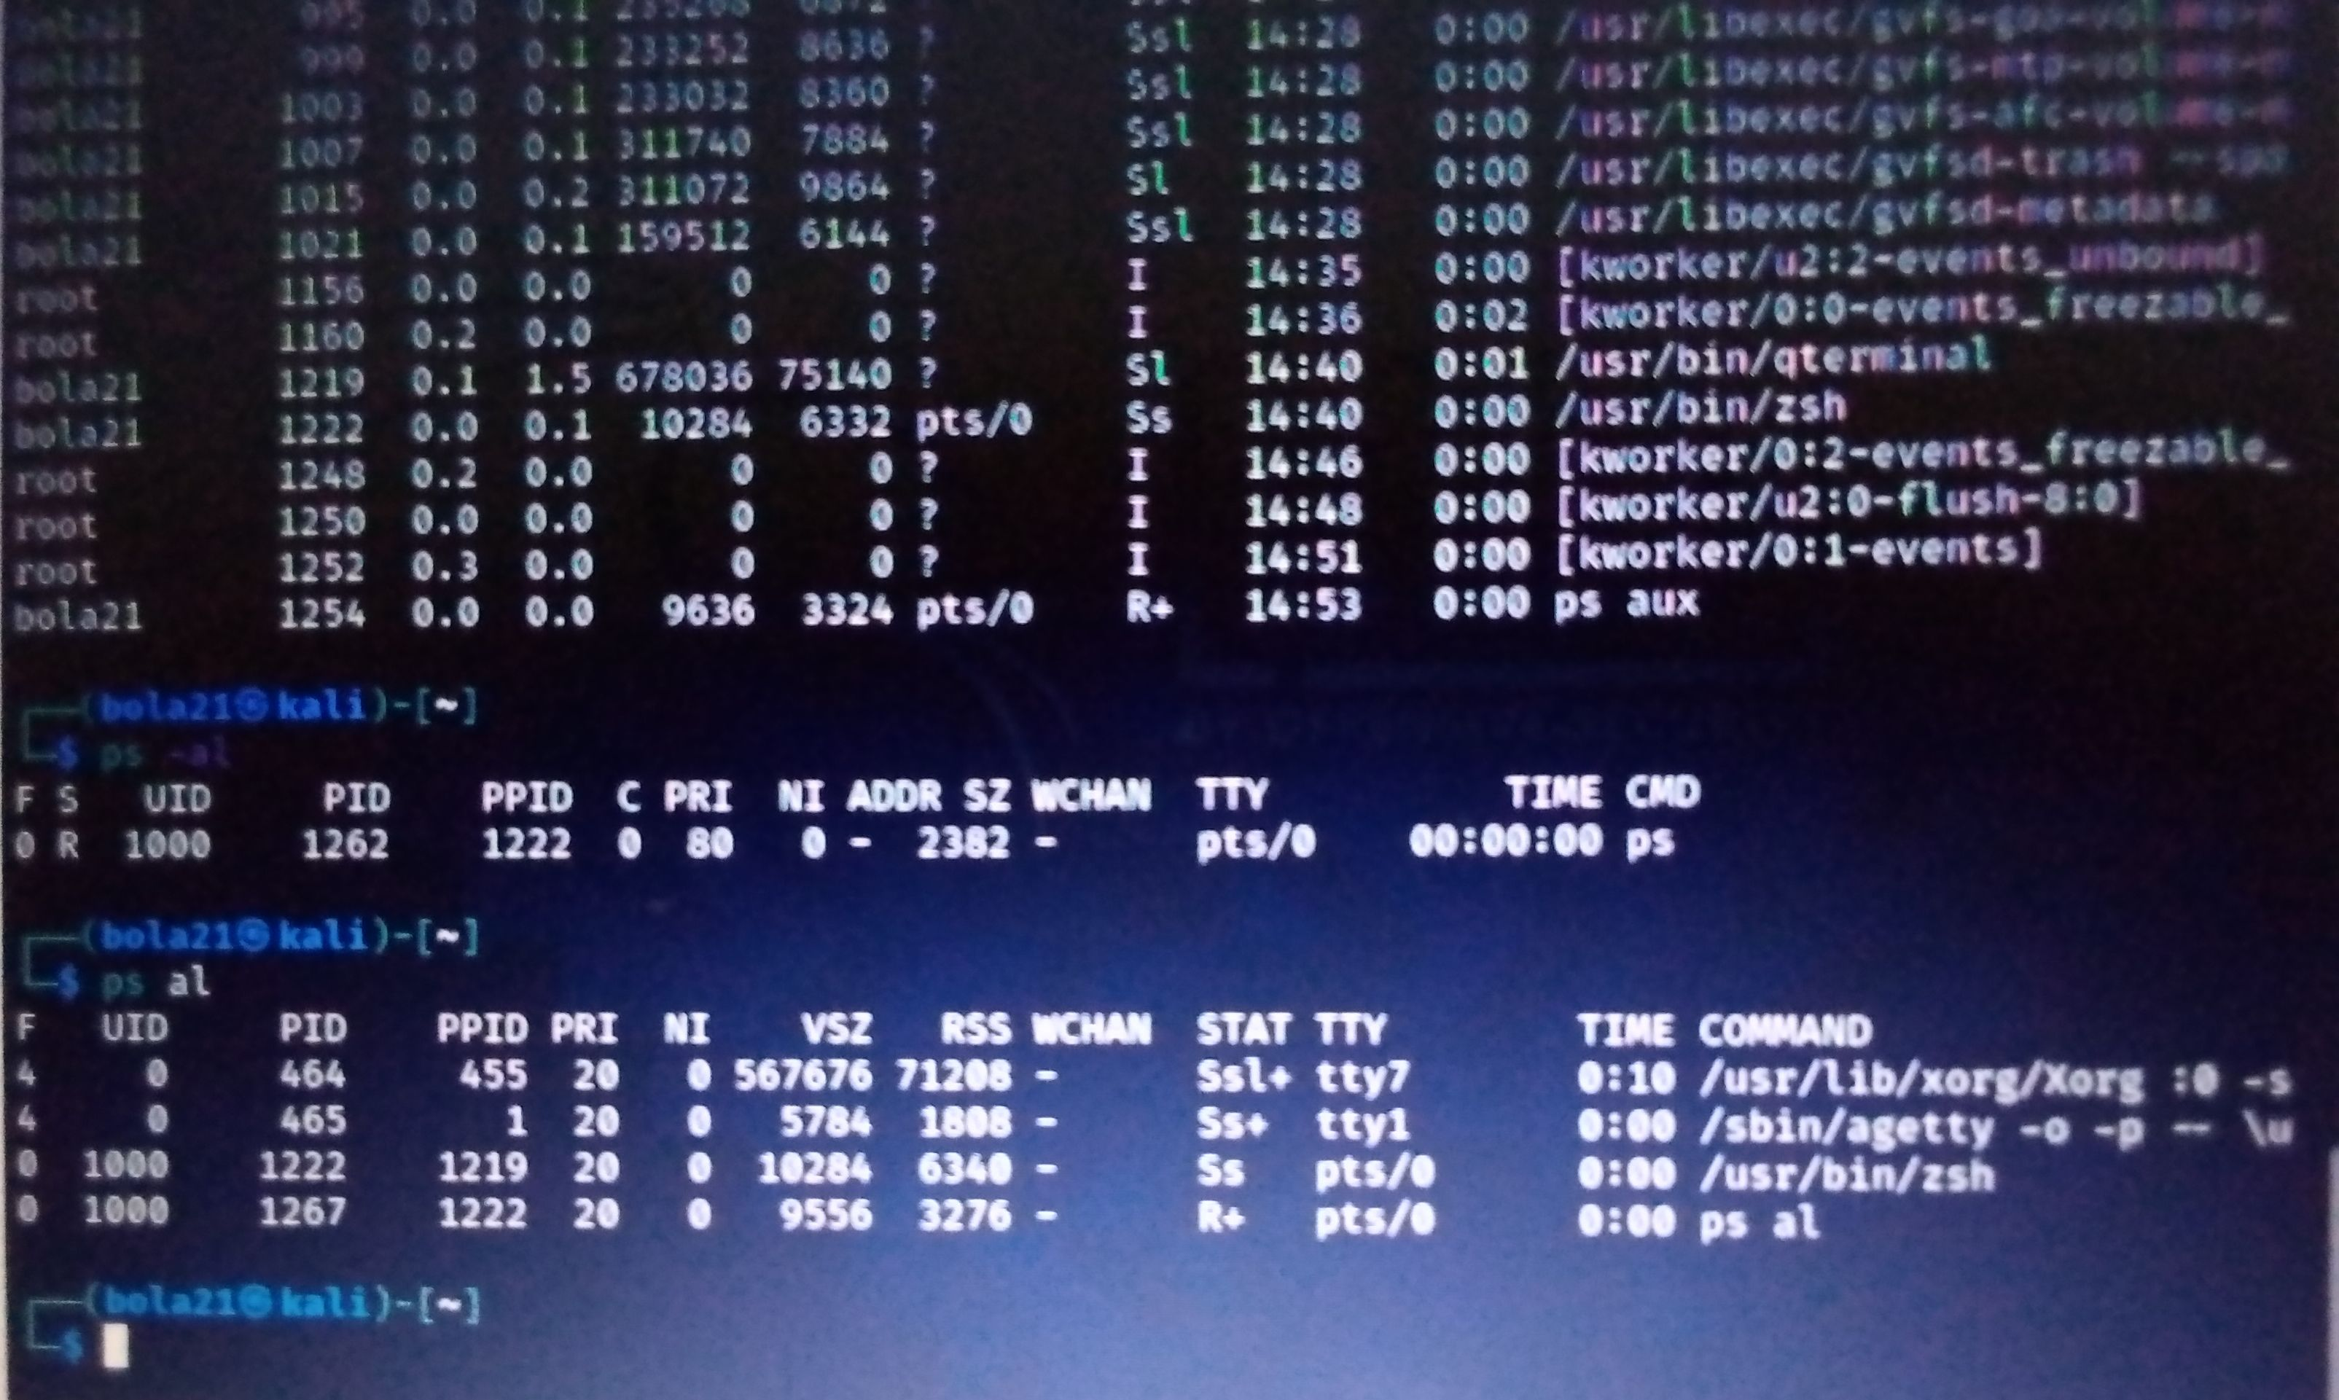

4. Change the priority of a process with default arguments.

5. Display Virtual Memory Statistics."vmstat"

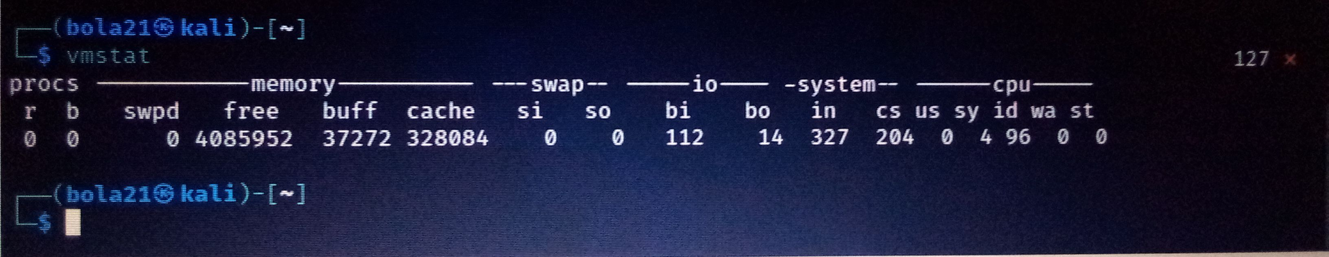

6. Display System Event Information.

7. Display Swapping Statistics."free -m"

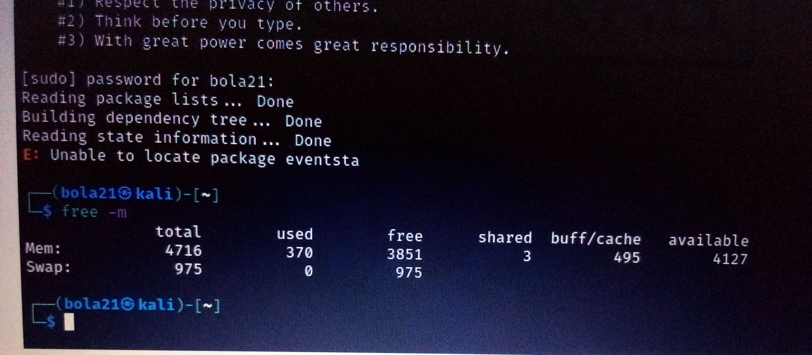

8. Check File Access statistics."last"

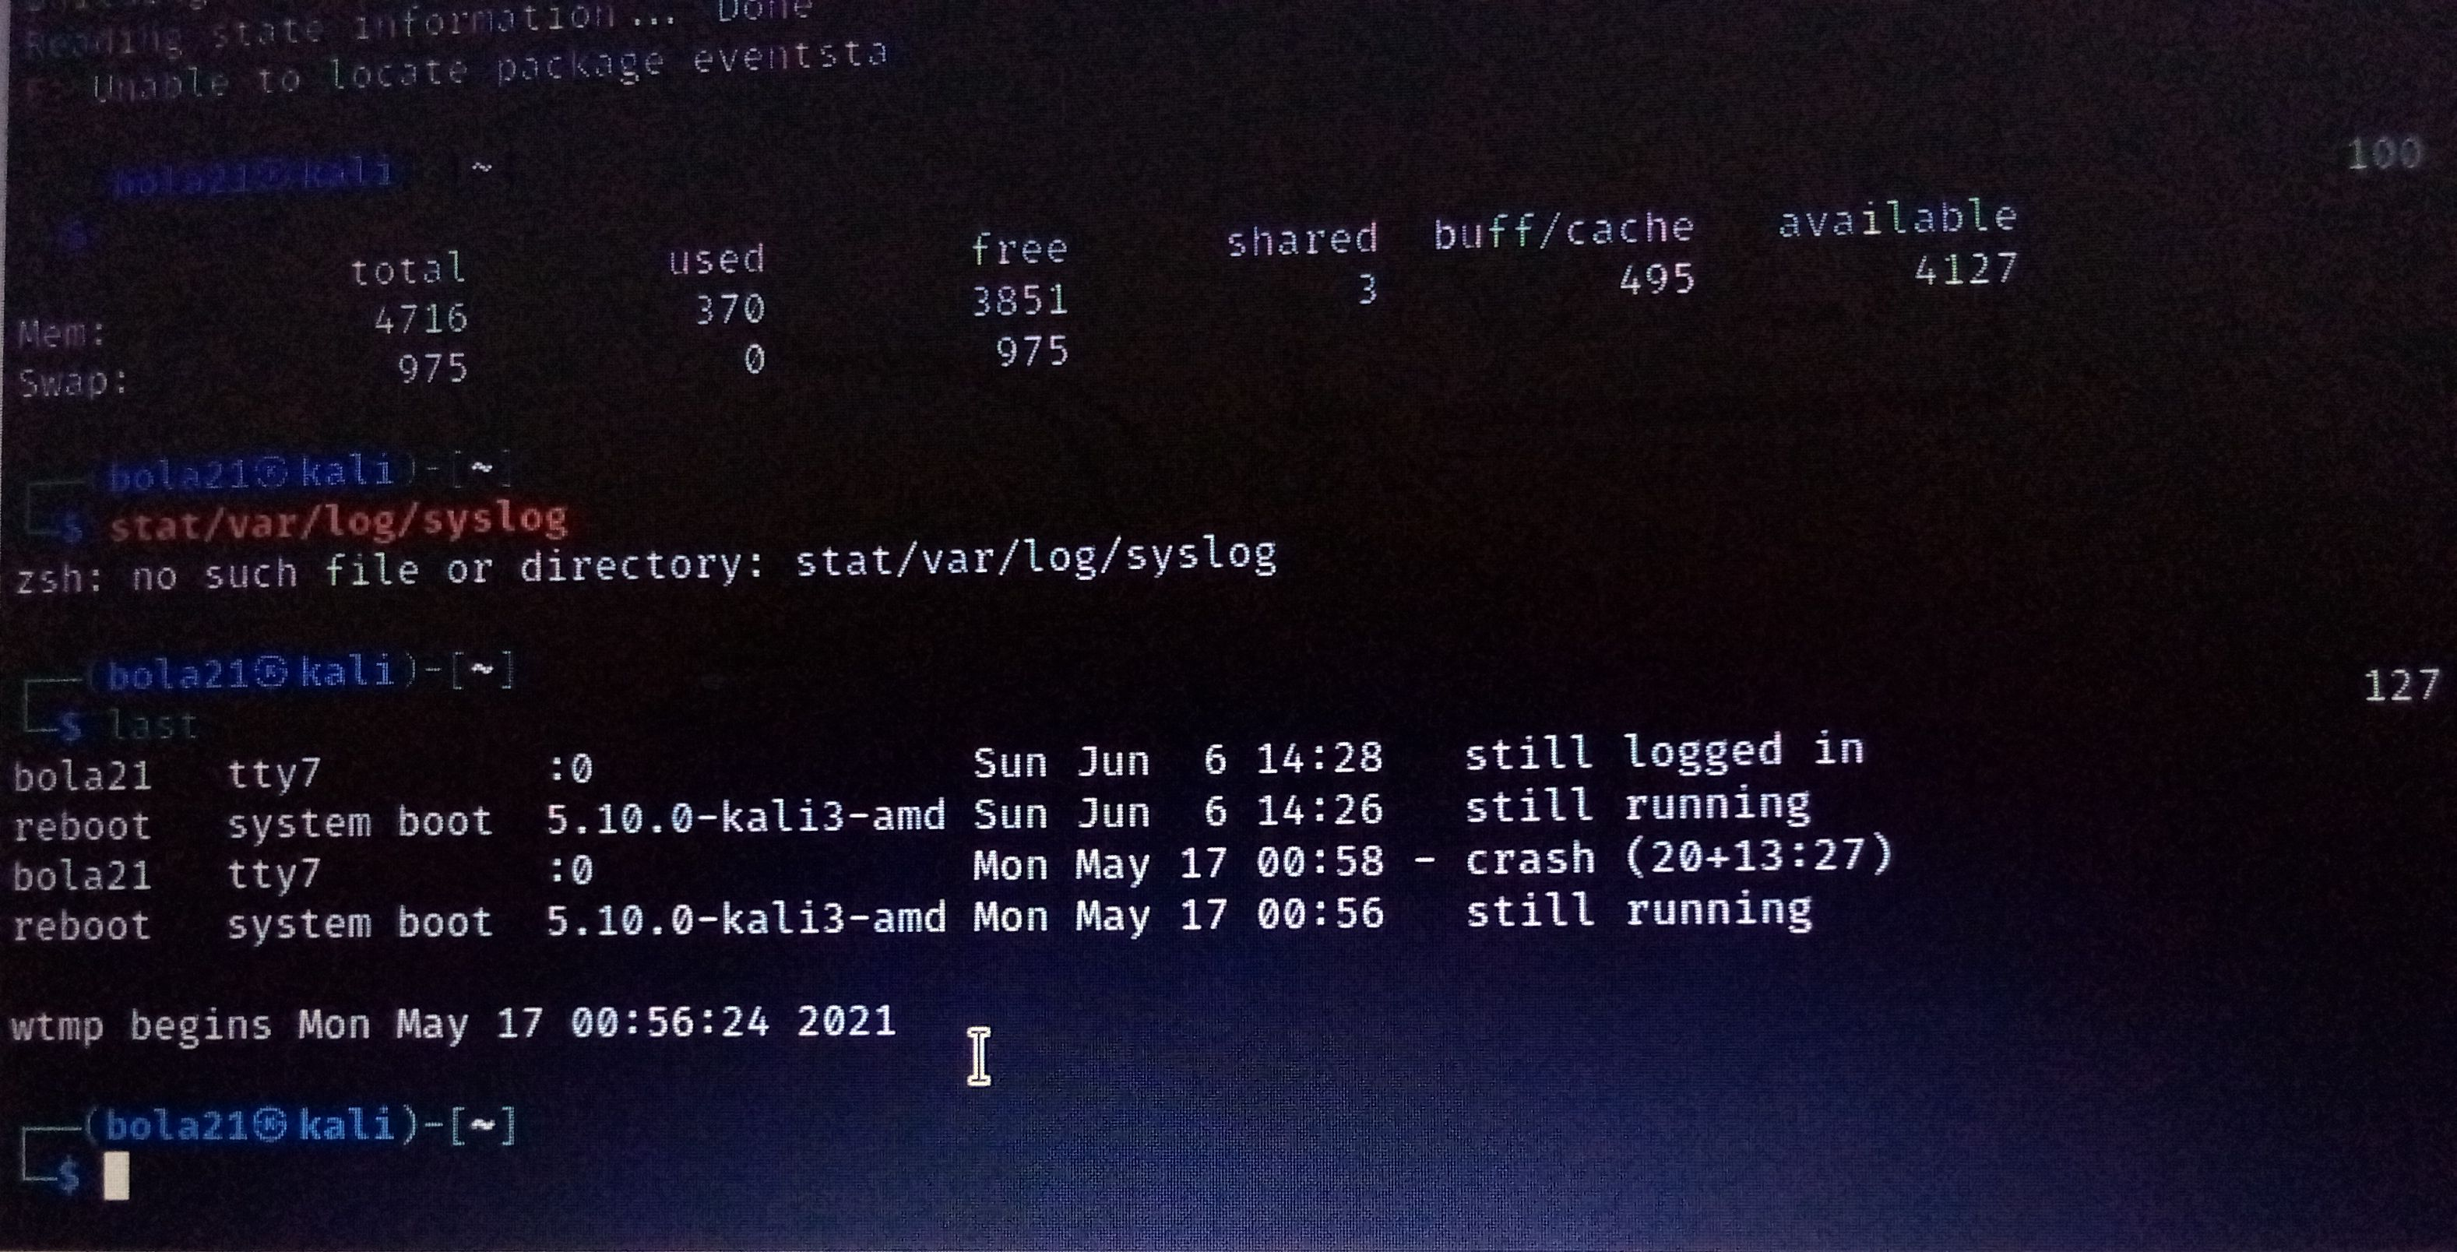

9. Check Buffer Activity statistics."sar -b"

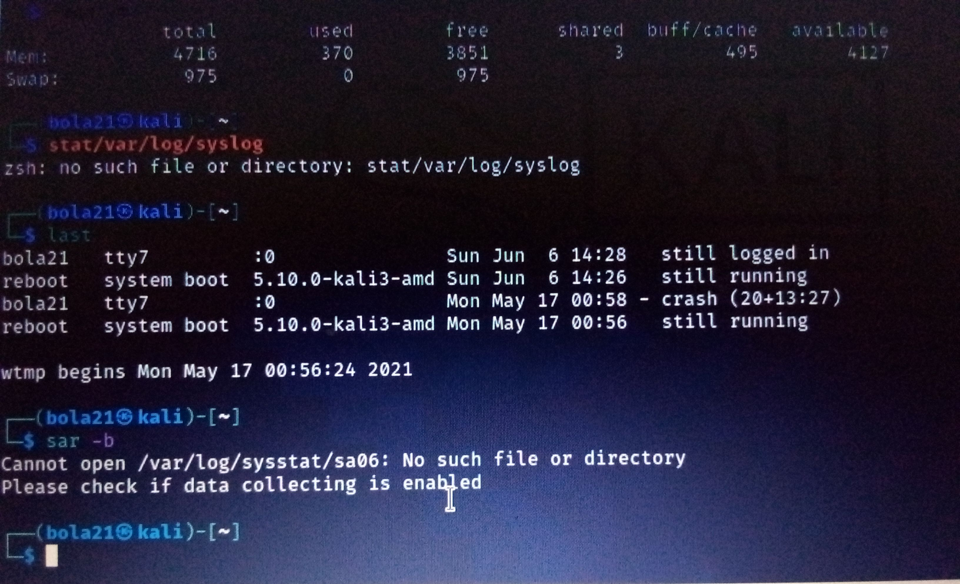

10. Check Disk Activity statistics."df"

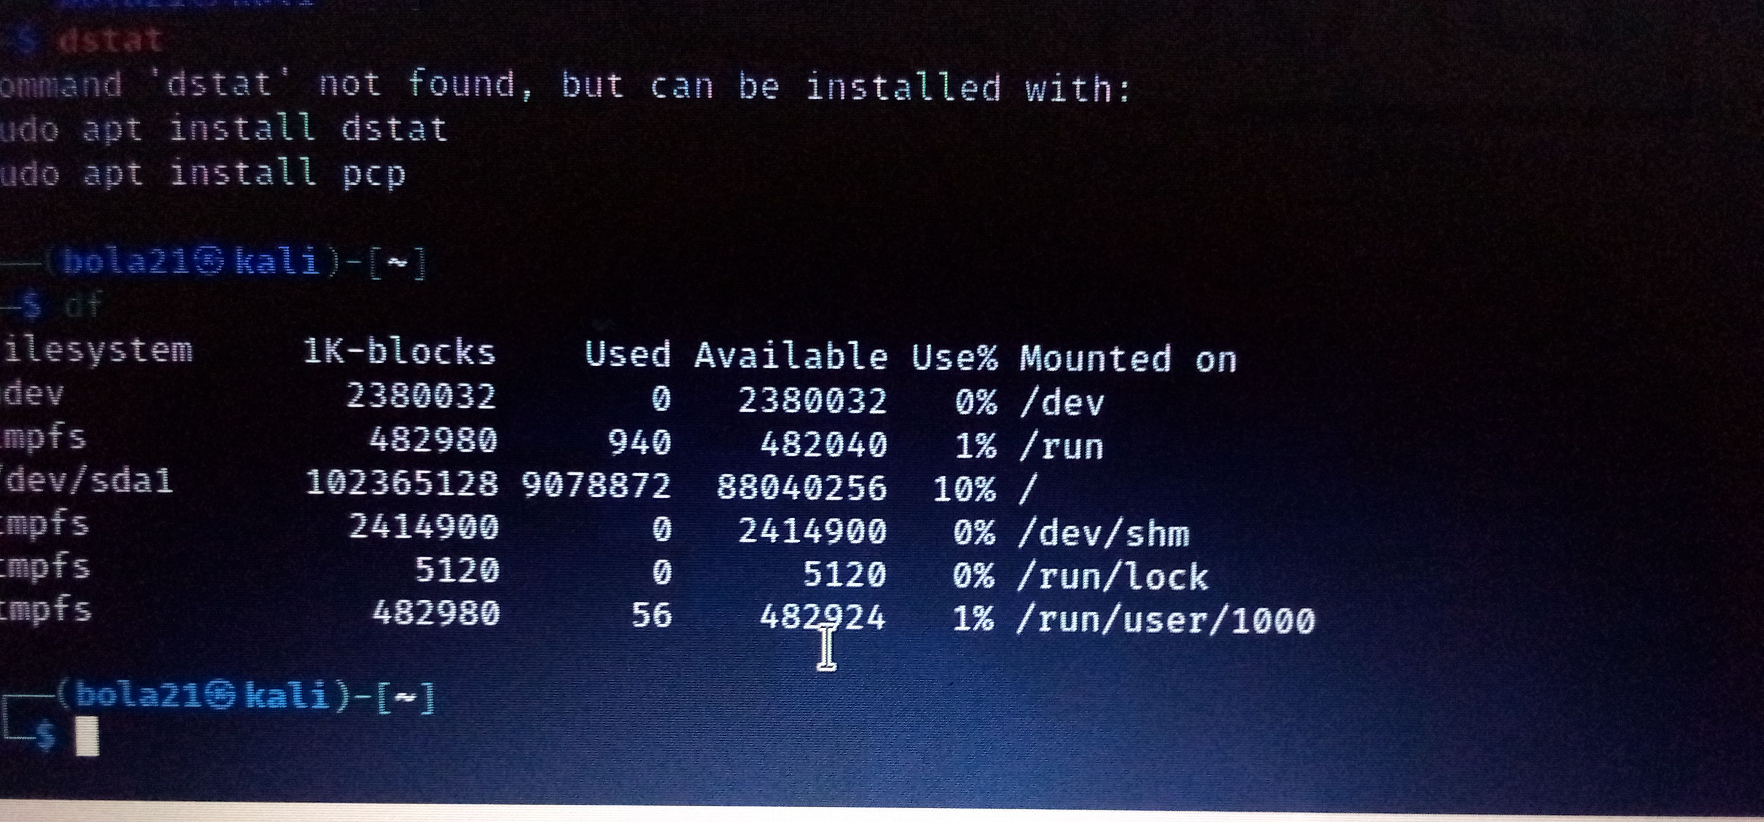

11. Check Inter process Communication statistics."ipcs"

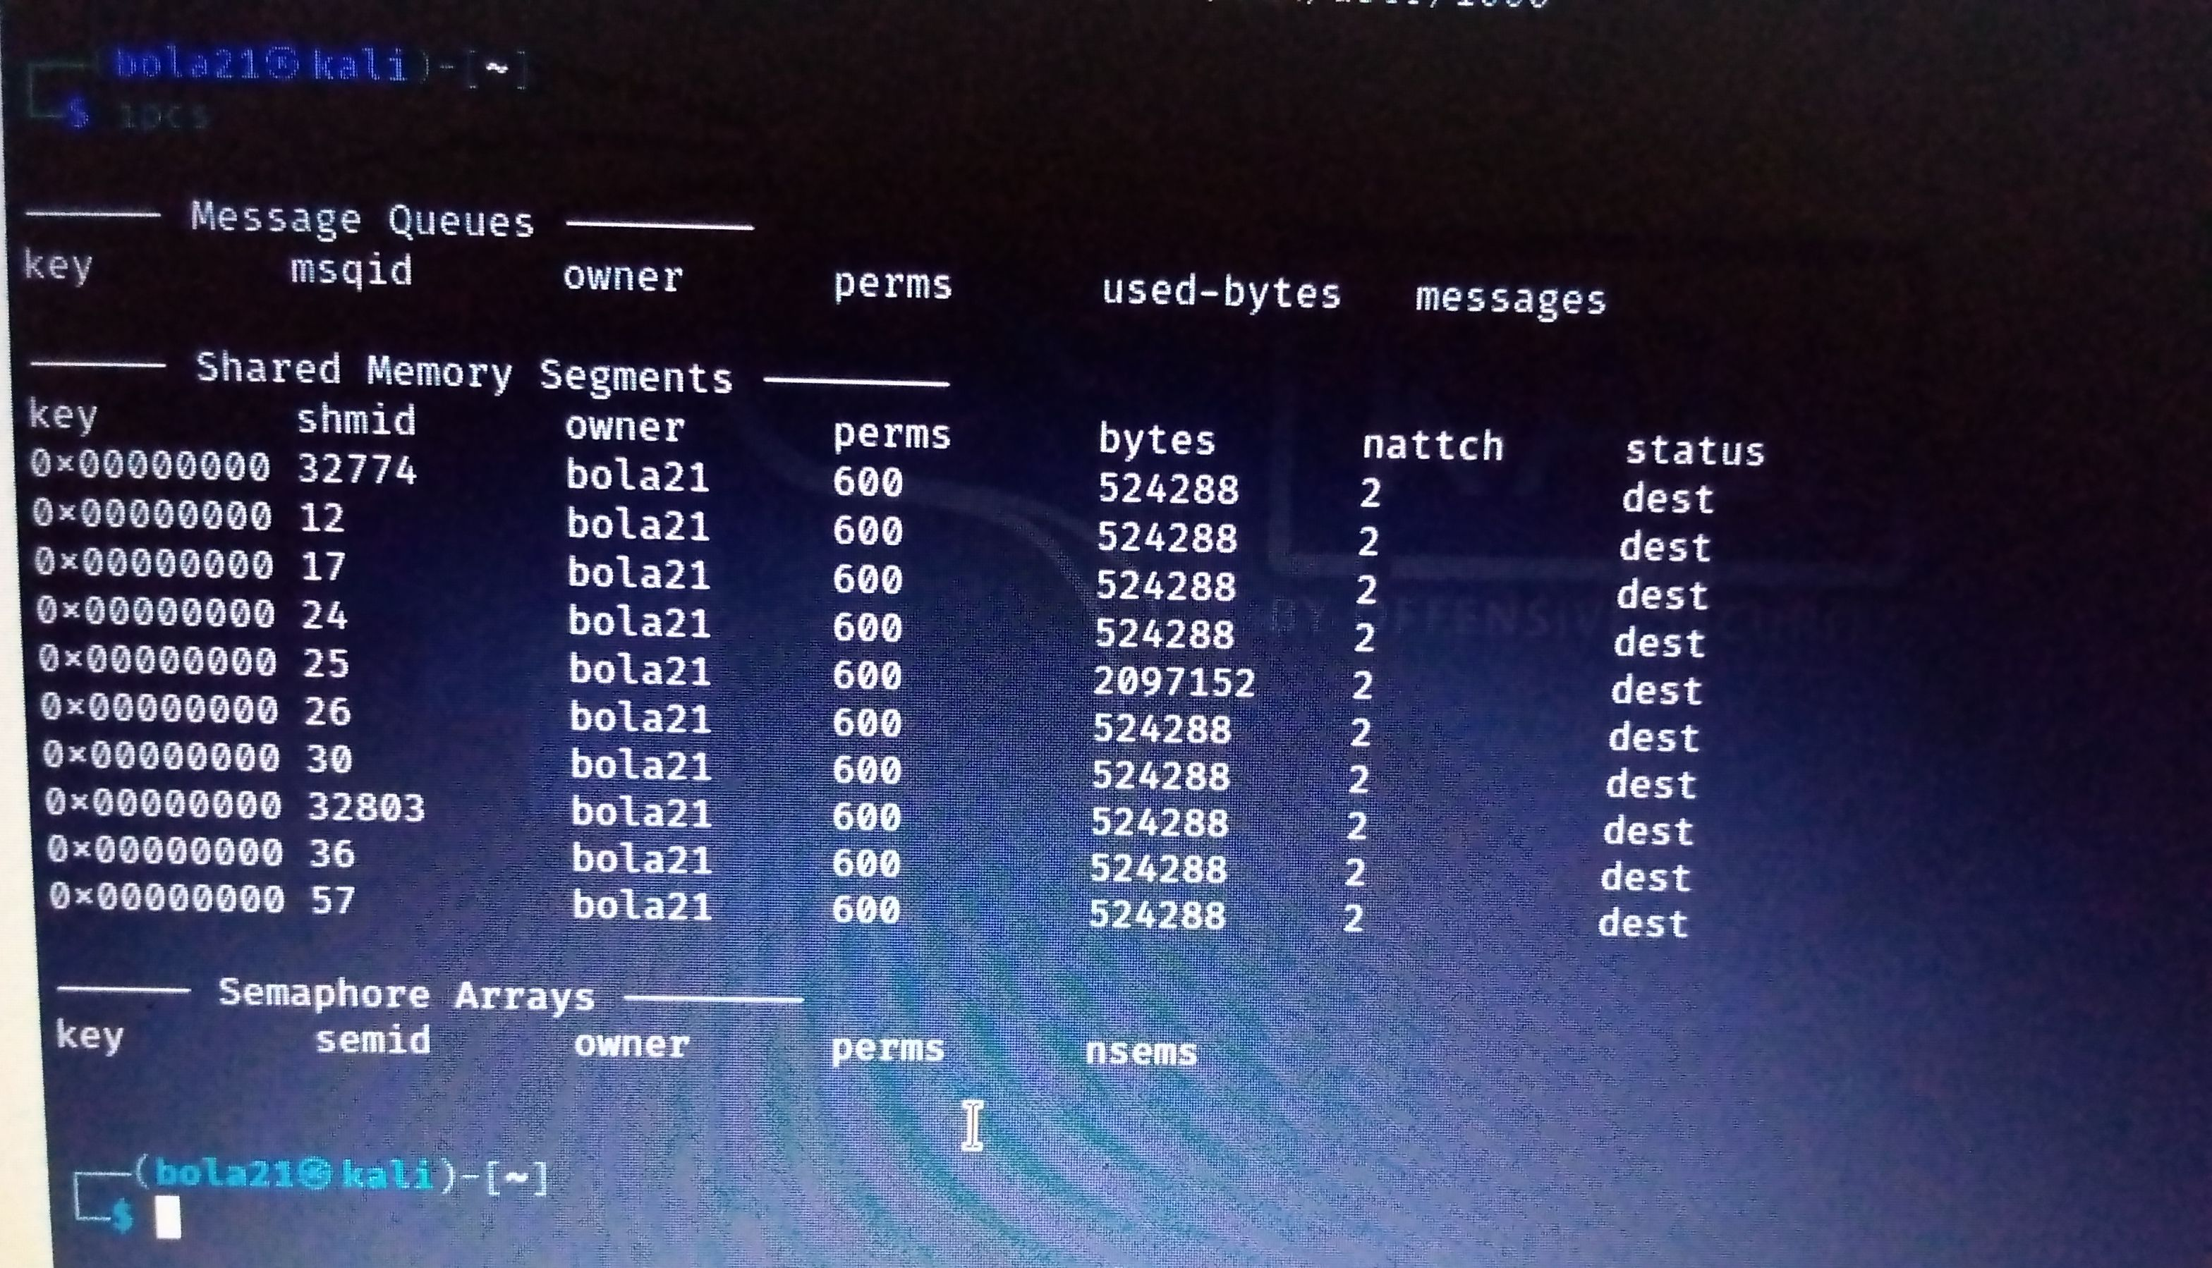

12. Check Unused Memory in the server. "Vmstat"

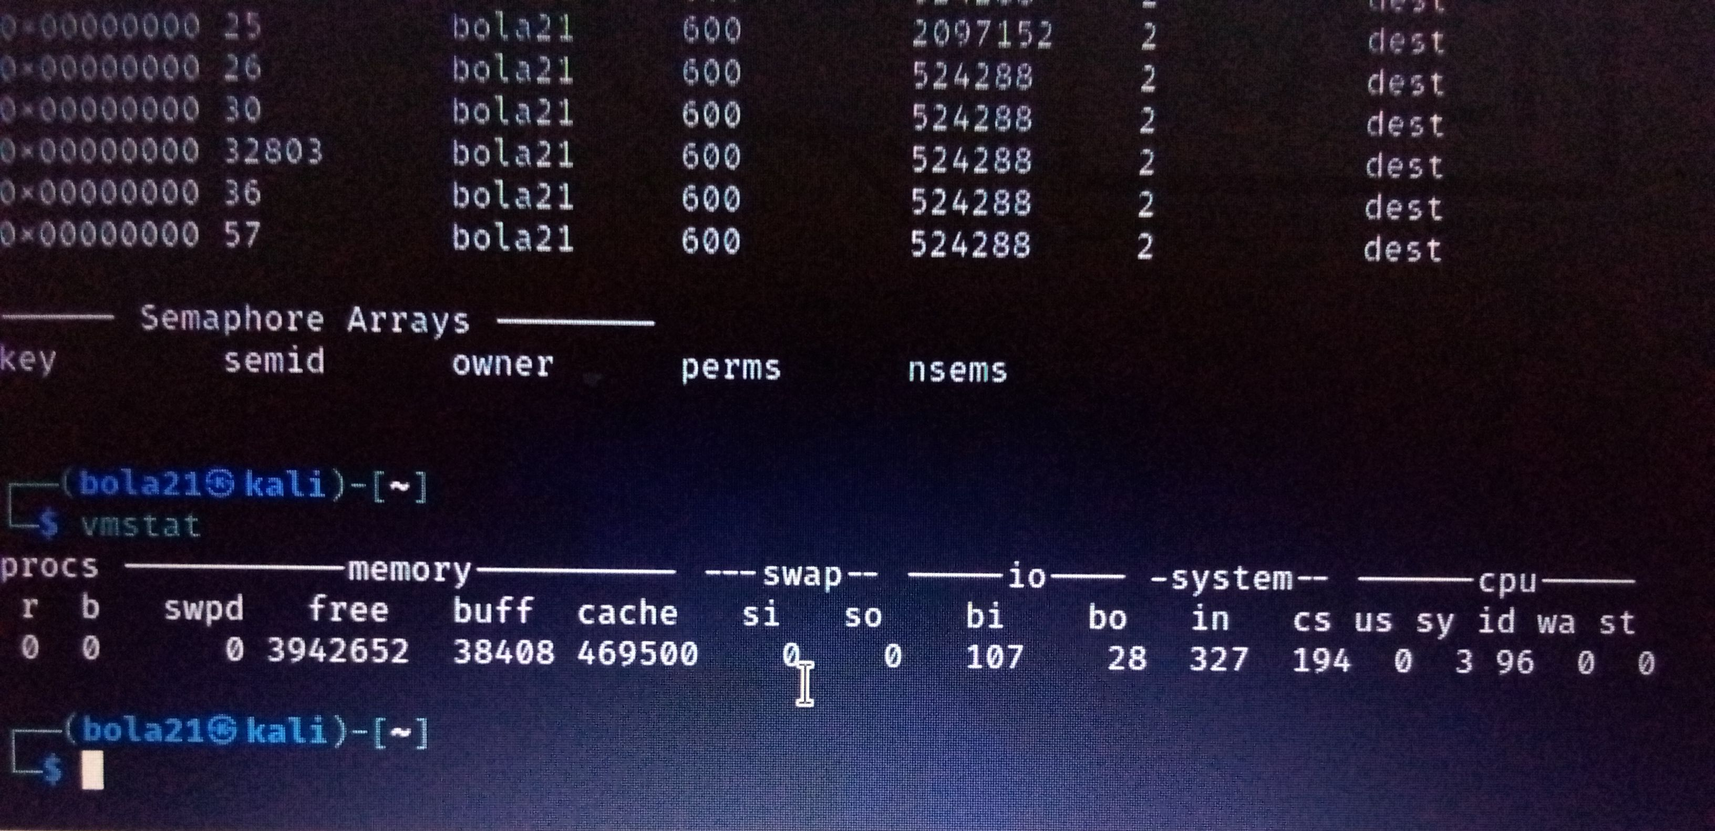

13. Check Swap Activities: "sar -w"

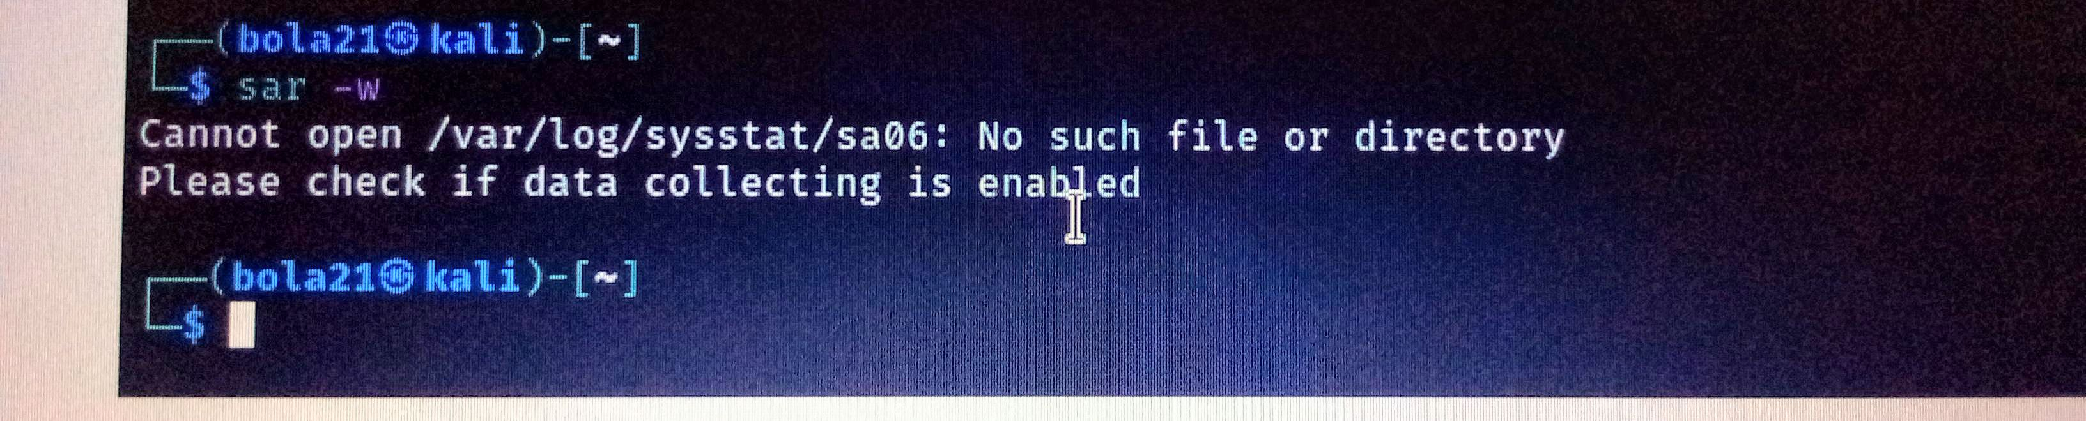

**Part 2 : Practical Activity Week 3**

This exercise is based on management of users accounts and creating of files. As linux

security Administrator you should be able to assign different file permission and revoke

permissions to unauthorized users. To improve your skills practice with this exercise.

Entirely use the Terminal utilization of GUI will not be awarded any marks.

